Thesis

Emma Vasen

null

Preliminary R setup and importing package

knitr::opts_chunk$set(echo = TRUE)  
  
install.packages("devtools")  
devtools::install_github("mikeblazanin/gcplyr")  
  
install.packages("lubridate")  
  
install.packages("tidyverse")

Importing data

library(gcplyr)  
  
Oct15Wide <- read_wides("2021-10-15 Data.csv")  
#get rid of the temperature column  
Oct15Wide <- Oct15Wide[,-3]  
  
Oct25Wide <- read_wides("2021-10-25 Data.csv")  
#get rid of the temperature column  
Oct25Wide <- Oct25Wide[,-3]  
  
Oct27Wide <- read_wides("2021-10-27 Data.csv")  
#get rid of the temperature column  
Oct27Wide <- Oct27Wide[,-3]  
  
Nov3Wide <- read_wides("2021-11-03 Data.csv")  
#get rid of the temperature column  
Nov3Wide <- Nov3Wide[,-3]

Transforming from wide-shaped to tidy-shaped

Oct15Tidy <- trans_wide_to_tidy(wides = Oct15Wide, id_cols = c("file", "Time"))  
  
Oct25Tidy <- trans_wide_to_tidy(wides = Oct25Wide, id_cols = c("file", "Time"))  
  
Oct27Tidy <- trans_wide_to_tidy(wides = Oct27Wide, id_cols = c("file", "Time"))  
  
Nov3Tidy <- trans_wide_to_tidy(wides = Nov3Wide, id_cols = c("file", "Time"))

Adding design elements

Oct15Design <- read.csv("2021-10-15 Design.csv")  
  
Oct25Design <- read.csv("2021-10-25 Design.csv")  
  
Oct27Design <- read.csv("2021-10-27 Design.csv")  
  
#October 25 and November 3 run have the same layout  
Nov3Design <- Oct25Design

Merging design elements with data

Oct15Merged <- merge_dfs(Oct15Tidy, Oct15Design)

## Joining, by = "Well"

head(Oct15Merged, 24)

## file Time Well Measurements Bacteria..cfu.mL. Phage..pfu.mL.  
## 1 2021-10-15 Data 0:14:16 A1 0.086 <NA> <NA>  
## 2 2021-10-15 Data 0:14:16 A2 0.086 <NA> <NA>  
## 3 2021-10-15 Data 0:14:16 A3 0.088 <NA> <NA>  
## 4 2021-10-15 Data 0:14:16 A4 0.090 <NA> <NA>  
## 5 2021-10-15 Data 0:14:16 A5 0.088 <NA> <NA>  
## 6 2021-10-15 Data 0:14:16 A6 0.085 <NA> <NA>  
## 7 2021-10-15 Data 0:14:16 A7 0.086 <NA> <NA>  
## 8 2021-10-15 Data 0:14:16 A8 0.087 <NA> <NA>  
## 9 2021-10-15 Data 0:14:16 A9 0.086 <NA> <NA>  
## 10 2021-10-15 Data 0:14:16 A10 0.087 <NA> <NA>  
## 11 2021-10-15 Data 0:14:16 A11 0.088 <NA> <NA>  
## 12 2021-10-15 Data 0:14:16 A12 0.089 <NA> <NA>  
## 13 2021-10-15 Data 0:14:16 B1 0.086 <NA> <NA>  
## 14 2021-10-15 Data 0:14:16 B2 0.084 <NA> <NA>  
## 15 2021-10-15 Data 0:14:16 B3 0.085 <NA> <NA>  
## 16 2021-10-15 Data 0:14:16 B4 0.082 <NA> <NA>  
## 17 2021-10-15 Data 0:14:16 B5 0.192 10^5 10^4  
## 18 2021-10-15 Data 0:14:16 B6 0.195 10^5 10^4  
## 19 2021-10-15 Data 0:14:16 B7 0.195 10^5 10^4  
## 20 2021-10-15 Data 0:14:16 B8 0.089 <NA> <NA>  
## 21 2021-10-15 Data 0:14:16 B9 0.088 <NA> <NA>  
## 22 2021-10-15 Data 0:14:16 B10 0.086 <NA> <NA>  
## 23 2021-10-15 Data 0:14:16 B11 0.086 <NA> <NA>  
## 24 2021-10-15 Data 0:14:16 B12 0.086 <NA> <NA>  
## Media  
## 1 <NA>  
## 2 <NA>  
## 3 <NA>  
## 4 <NA>  
## 5 <NA>  
## 6 <NA>  
## 7 <NA>  
## 8 <NA>  
## 9 <NA>  
## 10 <NA>  
## 11 <NA>  
## 12 <NA>  
## 13 <NA>  
## 14 KB Media  
## 15 KB Media  
## 16 KB Media  
## 17 KB Media  
## 18 KB Media  
## 19 KB Media  
## 20 <NA>  
## 21 <NA>  
## 22 <NA>  
## 23 <NA>  
## 24 <NA>

Oct25Merged <- merge_dfs(Oct25Tidy, Oct25Design)

## Joining, by = "Well"

head(Oct25Merged, 24)

## file Time Well Measurements Bacteria Phage.Added. Media  
## 1 2021-10-25 Data 0:14:16 A1 0.087 <NA> <NA> <NA>  
## 2 2021-10-25 Data 0:14:16 A2 0.086 <NA> <NA> <NA>  
## 3 2021-10-25 Data 0:14:16 A3 0.086 <NA> <NA> <NA>  
## 4 2021-10-25 Data 0:14:16 A4 0.087 <NA> <NA> <NA>  
## 5 2021-10-25 Data 0:14:16 A5 0.085 <NA> <NA> <NA>  
## 6 2021-10-25 Data 0:14:16 A6 0.085 <NA> <NA> <NA>  
## 7 2021-10-25 Data 0:14:16 A7 0.085 <NA> <NA> <NA>  
## 8 2021-10-25 Data 0:14:16 A8 0.085 <NA> <NA> <NA>  
## 9 2021-10-25 Data 0:14:16 A9 0.086 <NA> <NA> <NA>  
## 10 2021-10-25 Data 0:14:16 A10 0.086 <NA> <NA> <NA>  
## 11 2021-10-25 Data 0:14:16 A11 0.085 <NA> <NA> <NA>  
## 12 2021-10-25 Data 0:14:16 A12 0.085 <NA> <NA> <NA>  
## 13 2021-10-25 Data 0:14:16 B1 0.085 <NA> <NA> <NA>  
## 14 2021-10-25 Data 0:14:16 B2 0.145 PF Yes KB Media  
## 15 2021-10-25 Data 0:14:16 B3 0.143 PF Yes KB Media  
## 16 2021-10-25 Data 0:14:16 B4 0.149 PF Yes KB Media  
## 17 2021-10-25 Data 0:14:16 B5 0.149 7x CLD Yes KB Media  
## 18 2021-10-25 Data 0:14:16 B6 0.145 7x CLD Yes KB Media  
## 19 2021-10-25 Data 0:14:16 B7 0.146 7x CLD Yes KB Media  
## 20 2021-10-25 Data 0:14:16 B8 0.142 PF No KB Media  
## 21 2021-10-25 Data 0:14:16 B9 0.144 PF No KB Media  
## 22 2021-10-25 Data 0:14:16 B10 0.142 7x CLD No KB Media  
## 23 2021-10-25 Data 0:14:16 B11 0.145 7x CLD No KB Media  
## 24 2021-10-25 Data 0:14:16 B12 0.086 <NA> <NA> <NA>

Oct27Merged <- merge_dfs(Oct27Tidy, Oct27Design)

## Joining, by = "Well"

head(Oct27Merged, 24)

## file Time Well Measurements Bacteria Phage.Added. Media  
## 1 2021-10-27 Data 0:14:16 A1 0.086 <NA> <NA> <NA>  
## 2 2021-10-27 Data 0:14:16 A2 0.085 <NA> <NA> <NA>  
## 3 2021-10-27 Data 0:14:16 A3 0.086 <NA> <NA> <NA>  
## 4 2021-10-27 Data 0:14:16 A4 0.085 <NA> <NA> <NA>  
## 5 2021-10-27 Data 0:14:16 A5 0.085 <NA> <NA> <NA>  
## 6 2021-10-27 Data 0:14:16 A6 0.087 <NA> <NA> <NA>  
## 7 2021-10-27 Data 0:14:16 A7 0.085 <NA> <NA> <NA>  
## 8 2021-10-27 Data 0:14:16 A8 0.086 <NA> <NA> <NA>  
## 9 2021-10-27 Data 0:14:16 A9 0.088 <NA> <NA> <NA>  
## 10 2021-10-27 Data 0:14:16 A10 0.088 <NA> <NA> <NA>  
## 11 2021-10-27 Data 0:14:16 A11 0.088 <NA> <NA> <NA>  
## 12 2021-10-27 Data 0:14:16 A12 0.087 <NA> <NA> <NA>  
## 13 2021-10-27 Data 0:14:16 B1 0.088 <NA> <NA> <NA>  
## 14 2021-10-27 Data 0:14:16 B2 0.198 PF Yes KB Media  
## 15 2021-10-27 Data 0:14:16 B3 0.199 PF Yes KB Media  
## 16 2021-10-27 Data 0:14:16 B4 0.198 PF Yes KB Media  
## 17 2021-10-27 Data 0:14:16 B5 0.212 7x CLD Yes KB Media  
## 18 2021-10-27 Data 0:14:16 B6 0.208 7x CLD Yes KB Media  
## 19 2021-10-27 Data 0:14:16 B7 0.213 7x CLD Yes KB Media  
## 20 2021-10-27 Data 0:14:16 B8 0.194 PF No KB Media  
## 21 2021-10-27 Data 0:14:16 B9 0.197 PF No KB Media  
## 22 2021-10-27 Data 0:14:16 B10 0.205 7x CLD No KB Media  
## 23 2021-10-27 Data 0:14:16 B11 0.210 7x CLD No KB Media  
## 24 2021-10-27 Data 0:14:16 B12 0.086 <NA> <NA> <NA>

Nov3Merged <- merge_dfs(Nov3Tidy, Nov3Design)

## Joining, by = "Well"

head(Nov3Merged, 24)

## file Time Well Measurements Bacteria Phage.Added. Media  
## 1 2021-11-03 Data 0:14:16 A1 0.086 <NA> <NA> <NA>  
## 2 2021-11-03 Data 0:14:16 A2 0.085 <NA> <NA> <NA>  
## 3 2021-11-03 Data 0:14:16 A3 0.086 <NA> <NA> <NA>  
## 4 2021-11-03 Data 0:14:16 A4 0.087 <NA> <NA> <NA>  
## 5 2021-11-03 Data 0:14:16 A5 0.086 <NA> <NA> <NA>  
## 6 2021-11-03 Data 0:14:16 A6 0.085 <NA> <NA> <NA>  
## 7 2021-11-03 Data 0:14:16 A7 0.085 <NA> <NA> <NA>  
## 8 2021-11-03 Data 0:14:16 A8 0.085 <NA> <NA> <NA>  
## 9 2021-11-03 Data 0:14:16 A9 0.086 <NA> <NA> <NA>  
## 10 2021-11-03 Data 0:14:16 A10 0.087 <NA> <NA> <NA>  
## 11 2021-11-03 Data 0:14:16 A11 0.088 <NA> <NA> <NA>  
## 12 2021-11-03 Data 0:14:16 A12 0.087 <NA> <NA> <NA>  
## 13 2021-11-03 Data 0:14:16 B1 0.086 <NA> <NA> <NA>  
## 14 2021-11-03 Data 0:14:16 B2 0.206 PF Yes KB Media  
## 15 2021-11-03 Data 0:14:16 B3 0.210 PF Yes KB Media  
## 16 2021-11-03 Data 0:14:16 B4 0.209 PF Yes KB Media  
## 17 2021-11-03 Data 0:14:16 B5 0.213 7x CLD Yes KB Media  
## 18 2021-11-03 Data 0:14:16 B6 0.211 7x CLD Yes KB Media  
## 19 2021-11-03 Data 0:14:16 B7 0.215 7x CLD Yes KB Media  
## 20 2021-11-03 Data 0:14:16 B8 0.207 PF No KB Media  
## 21 2021-11-03 Data 0:14:16 B9 0.204 PF No KB Media  
## 22 2021-11-03 Data 0:14:16 B10 0.222 7x CLD No KB Media  
## 23 2021-11-03 Data 0:14:16 B11 0.213 7x CLD No KB Media  
## 24 2021-11-03 Data 0:14:16 B12 0.085 <NA> <NA> <NA>

Smoothing Data

#need to convert time to seconds  
library(lubridate)

## Warning: package 'lubridate' was built under R version 4.0.5

##   
## Attaching package: 'lubridate'

## The following objects are masked from 'package:base':  
##   
## date, intersect, setdiff, union

library(tidyverse)

## Warning: package 'tidyverse' was built under R version 4.0.5

## -- Attaching packages --------------------------------------- tidyverse 1.3.1 --

## v ggplot2 3.3.3 v purrr 0.3.4  
## v tibble 3.1.2 v dplyr 1.0.6  
## v tidyr 1.1.3 v stringr 1.4.0  
## v readr 1.4.0 v forcats 0.5.1

## Warning: package 'ggplot2' was built under R version 4.0.5

## Warning: package 'tibble' was built under R version 4.0.5

## Warning: package 'tidyr' was built under R version 4.0.5

## Warning: package 'dplyr' was built under R version 4.0.5

## -- Conflicts ------------------------------------------ tidyverse_conflicts() --  
## x lubridate::as.difftime() masks base::as.difftime()  
## x lubridate::date() masks base::date()  
## x dplyr::filter() masks stats::filter()  
## x lubridate::intersect() masks base::intersect()  
## x dplyr::lag() masks stats::lag()  
## x lubridate::setdiff() masks base::setdiff()  
## x lubridate::union() masks base::union()

#Oct15Data  
Oct15Merged$TimeSecs <- hms(Oct15Merged$Time)  
Oct15Merged$TimeSecs <- 3600*hour(Oct15Merged$TimeSecs) + 60*minute(Oct15Merged$TimeSecs) + second(Oct15Merged$TimeSecs)  
  
Oct15Merged$smoothed <- smooth_data(x = Oct15Merged$TimeSecs,  
 y = Oct15Merged$Measurements,  
 method = "moving-average",  
 subset_by = Oct15Merged$Well,  
 window_width = 5)  
  
Oct15Merged2 <- Oct15Merged[complete.cases(Oct15Merged[, c("Bacteria..cfu.mL.", "Phage..pfu.mL.", "Media")]), ]  
head(Oct15Merged2, 24)

## file Time Well Measurements Bacteria..cfu.mL. Phage..pfu.mL.  
## 17 2021-10-15 Data 0:14:16 B5 0.192 10^5 10^4  
## 18 2021-10-15 Data 0:14:16 B6 0.195 10^5 10^4  
## 19 2021-10-15 Data 0:14:16 B7 0.195 10^5 10^4  
## 29 2021-10-15 Data 0:14:16 C5 0.186 10^5 10^3  
## 30 2021-10-15 Data 0:14:16 C6 0.193 10^5 10^3  
## 31 2021-10-15 Data 0:14:16 C7 0.200 10^5 10^3  
## 41 2021-10-15 Data 0:14:16 D5 0.191 10^5 10^2  
## 42 2021-10-15 Data 0:14:16 D6 0.202 10^5 10^2  
## 43 2021-10-15 Data 0:14:16 D7 0.198 10^5 10^2  
## 53 2021-10-15 Data 0:14:16 E5 0.098 10^4 10^3  
## 54 2021-10-15 Data 0:14:16 E6 0.096 10^4 10^3  
## 55 2021-10-15 Data 0:14:16 E7 0.096 10^4 10^3  
## 62 2021-10-15 Data 0:14:16 F2 0.126 5 x 10^4 5 x 10^3  
## 63 2021-10-15 Data 0:14:16 F3 0.136 5 x 10^4 5 x 10^3  
## 64 2021-10-15 Data 0:14:16 F4 0.128 5 x 10^4 5 x 10^3  
## 65 2021-10-15 Data 0:14:16 F5 0.101 10^4 10^2  
## 66 2021-10-15 Data 0:14:16 F6 0.099 10^4 10^2  
## 67 2021-10-15 Data 0:14:16 F7 0.096 10^4 10^2  
## 74 2021-10-15 Data 0:14:16 G2 0.140 5 x 10^4 5 x 10^2  
## 75 2021-10-15 Data 0:14:16 G3 0.132 5 x 10^4 5 x 10^2  
## 76 2021-10-15 Data 0:14:16 G4 0.134 5 x 10^4 5 x 10^2  
## 113 2021-10-15 Data 0:29:16 B5 0.189 10^5 10^4  
## 114 2021-10-15 Data 0:29:16 B6 0.186 10^5 10^4  
## 115 2021-10-15 Data 0:29:16 B7 0.189 10^5 10^4  
## Media TimeSecs smoothed  
## 17 KB Media 856 NA  
## 18 KB Media 856 NA  
## 19 KB Media 856 NA  
## 29 KB Media 856 NA  
## 30 KB Media 856 NA  
## 31 KB Media 856 NA  
## 41 KB Media 856 NA  
## 42 KB Media 856 NA  
## 43 KB Media 856 NA  
## 53 KB Media 856 NA  
## 54 KB Media 856 NA  
## 55 KB Media 856 NA  
## 62 KB Media 856 NA  
## 63 KB Media 856 NA  
## 64 KB Media 856 NA  
## 65 KB Media 856 NA  
## 66 KB Media 856 NA  
## 67 KB Media 856 NA  
## 74 KB Media 856 NA  
## 75 KB Media 856 NA  
## 76 KB Media 856 NA  
## 113 KB Media 1756 NA  
## 114 KB Media 1756 NA  
## 115 KB Media 1756 NA

ggplot(data = Oct15Merged2, aes(x = TimeSecs, y = Measurements)) + geom_point(aes(color = Well)) + ggtitle("Oct15 Original")

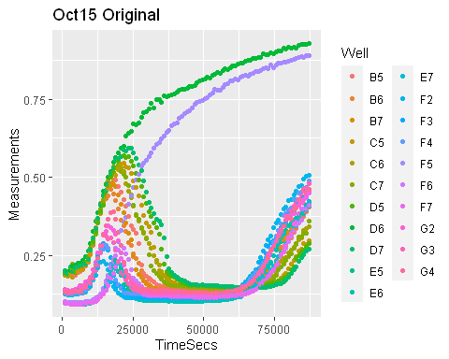

ggplot(data = Oct15Merged2, aes(x = TimeSecs, y = smoothed)) + geom_point(aes(color = Well)) + ggtitle("Oct15 Smoothed")

## Warning: Removed 84 rows containing missing values (geom_point).

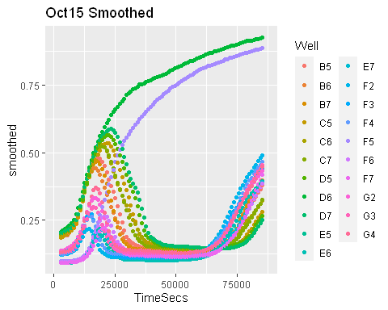

plot(Oct15Merged$TimeSecs[Oct15Merged$Well == "B5"], Oct15Merged$Measurements[Oct15Merged$Well == "B5"], xlab = "Time in seconds", ylab = "Absorbance", main = "Oct15 Cell B5 Original")

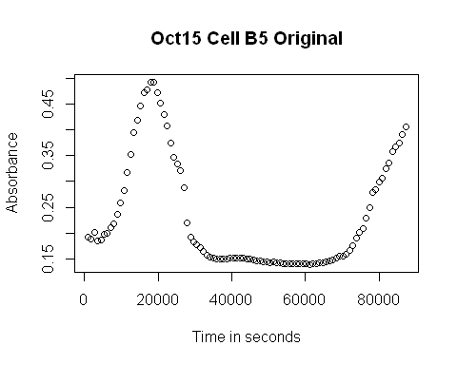

plot(Oct15Merged$TimeSecs[Oct15Merged$Well == "B5"], Oct15Merged$smoothed[Oct15Merged$Well == "B5"], xlab = "Time in seconds", ylab = "Smoothed Absorbance", main = "Oct15 Cell B5 Smoothed")

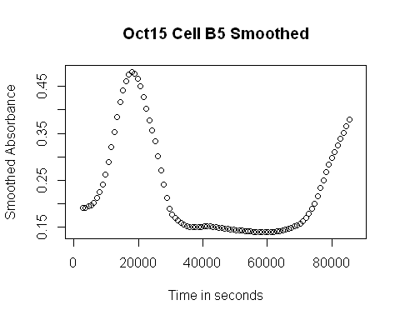

#Oct25Data  
Oct25Merged$TimeSecs <- hms(Oct25Merged$Time)  
Oct25Merged$TimeSecs <- 3600*hour(Oct25Merged$TimeSecs) + 60*minute(Oct25Merged$TimeSecs) + second(Oct25Merged$TimeSecs)  
  
Oct25Merged$smoothed <- smooth_data(x = Oct25Merged$TimeSecs,  
 y = Oct25Merged$Measurements,  
 method = "moving-average",  
 subset_by = Oct25Merged$Well,  
 window_width = 5)  
  
Oct25Merged2 <- Oct25Merged[complete.cases(Oct25Merged[, c("Bacteria", "Phage.Added.", "Media")]), ]  
head(Oct25Merged2, 24)

## file Time Well Measurements Bacteria Phage.Added. Media  
## 14 2021-10-25 Data 0:14:16 B2 0.145 PF Yes KB Media  
## 15 2021-10-25 Data 0:14:16 B3 0.143 PF Yes KB Media  
## 16 2021-10-25 Data 0:14:16 B4 0.149 PF Yes KB Media  
## 17 2021-10-25 Data 0:14:16 B5 0.149 7x CLD Yes KB Media  
## 18 2021-10-25 Data 0:14:16 B6 0.145 7x CLD Yes KB Media  
## 19 2021-10-25 Data 0:14:16 B7 0.146 7x CLD Yes KB Media  
## 20 2021-10-25 Data 0:14:16 B8 0.142 PF No KB Media  
## 21 2021-10-25 Data 0:14:16 B9 0.144 PF No KB Media  
## 22 2021-10-25 Data 0:14:16 B10 0.142 7x CLD No KB Media  
## 23 2021-10-25 Data 0:14:16 B11 0.145 7x CLD No KB Media  
## 26 2021-10-25 Data 0:14:16 C2 0.148 125 ALE Yes KB Media  
## 27 2021-10-25 Data 0:14:16 C3 0.153 125 ALE Yes KB Media  
## 28 2021-10-25 Data 0:14:16 C4 0.164 125 ALE Yes KB Media  
## 29 2021-10-25 Data 0:14:16 C5 0.155 7x EGD Yes KB Media  
## 30 2021-10-25 Data 0:14:16 C6 0.157 7x EGD Yes KB Media  
## 31 2021-10-25 Data 0:14:16 C7 0.162 7x EGD Yes KB Media  
## 32 2021-10-25 Data 0:14:16 C8 0.147 125 ALE No KB Media  
## 33 2021-10-25 Data 0:14:16 C9 0.151 125 ALE No KB Media  
## 34 2021-10-25 Data 0:14:16 C10 0.159 7x EGD No KB Media  
## 35 2021-10-25 Data 0:14:16 C11 0.159 7x EGD No KB Media  
## 38 2021-10-25 Data 0:14:16 D2 0.156 7x EGC Yes KB Media  
## 39 2021-10-25 Data 0:14:16 D3 0.160 7x EGC Yes KB Media  
## 40 2021-10-25 Data 0:14:16 D4 0.160 7x EGC Yes KB Media  
## 41 2021-10-25 Data 0:14:16 D5 0.144 7x ALA Yes KB Media  
## TimeSecs smoothed  
## 14 856 NA  
## 15 856 NA  
## 16 856 NA  
## 17 856 NA  
## 18 856 NA  
## 19 856 NA  
## 20 856 NA  
## 21 856 NA  
## 22 856 NA  
## 23 856 NA  
## 26 856 NA  
## 27 856 NA  
## 28 856 NA  
## 29 856 NA  
## 30 856 NA  
## 31 856 NA  
## 32 856 NA  
## 33 856 NA  
## 34 856 NA  
## 35 856 NA  
## 38 856 NA  
## 39 856 NA  
## 40 856 NA  
## 41 856 NA

ggplot(data = Oct25Merged2, aes(x = TimeSecs, y = Measurements)) + geom_point(aes(color = Well)) + ggtitle("Oct25 Original")

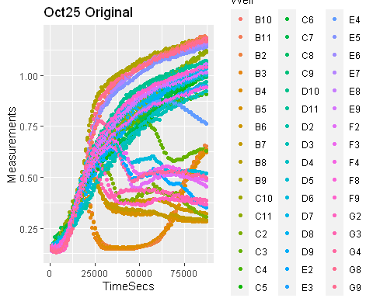

ggplot(data = Oct25Merged2, aes(x = TimeSecs, y = smoothed)) + geom_point(aes(color = Well)) + ggtitle("Oct25 Smoothed")

## Warning: Removed 192 rows containing missing values (geom_point).

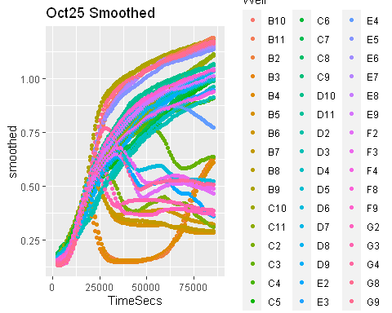

plot(Oct25Merged$TimeSecs[Oct25Merged$Well == "B5"], Oct25Merged$Measurements[Oct25Merged$Well == "B5"], xlab = "Time in seconds", ylab = "Absorbance", main = "Oct25 Cell B5 Original")

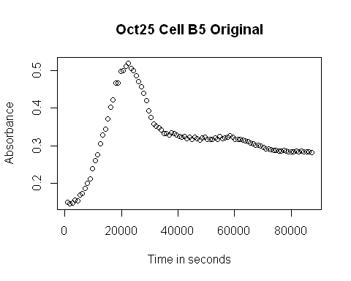

plot(Oct25Merged$TimeSecs[Oct25Merged$Well == "B5"], Oct25Merged$smoothed[Oct25Merged$Well == "B5"], xlab = "Time in seconds", ylab = "Smoothed Absorbance", main = "Oct25 Cell B5 Smoothed")

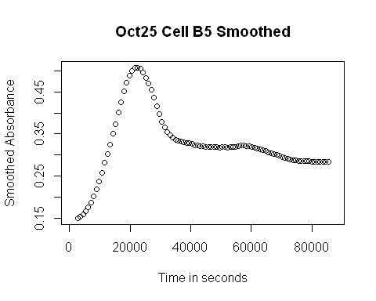

#Oct27Data  
Oct27Merged$TimeSecs <- hms(Oct27Merged$Time)  
Oct27Merged$TimeSecs <- 3600*hour(Oct27Merged$TimeSecs) + 60*minute(Oct27Merged$TimeSecs) + second(Oct27Merged$TimeSecs)  
  
Oct27Merged$smoothed <- smooth_data(x = Oct27Merged$TimeSecs,  
 y = Oct27Merged$Measurements,  
 method = "moving-average",  
 subset_by = Oct27Merged$Well,  
 window_width = 5)  
  
Oct27Merged2 <- Oct27Merged[complete.cases(Oct27Merged[, c("Bacteria", "Phage.Added.", "Media")]), ]  
head(Oct27Merged2, 24)

## file Time Well Measurements Bacteria Phage.Added. Media  
## 14 2021-10-27 Data 0:14:16 B2 0.198 PF Yes KB Media  
## 15 2021-10-27 Data 0:14:16 B3 0.199 PF Yes KB Media  
## 16 2021-10-27 Data 0:14:16 B4 0.198 PF Yes KB Media  
## 17 2021-10-27 Data 0:14:16 B5 0.212 7x CLD Yes KB Media  
## 18 2021-10-27 Data 0:14:16 B6 0.208 7x CLD Yes KB Media  
## 19 2021-10-27 Data 0:14:16 B7 0.213 7x CLD Yes KB Media  
## 20 2021-10-27 Data 0:14:16 B8 0.194 PF No KB Media  
## 21 2021-10-27 Data 0:14:16 B9 0.197 PF No KB Media  
## 22 2021-10-27 Data 0:14:16 B10 0.205 7x CLD No KB Media  
## 23 2021-10-27 Data 0:14:16 B11 0.210 7x CLD No KB Media  
## 26 2021-10-27 Data 0:14:16 C2 0.208 125 ALE Yes KB Media  
## 27 2021-10-27 Data 0:14:16 C3 0.206 125 ALE Yes KB Media  
## 28 2021-10-27 Data 0:14:16 C4 0.194 125 ALE Yes KB Media  
## 29 2021-10-27 Data 0:14:16 C5 0.219 7x EGD Yes KB Media  
## 30 2021-10-27 Data 0:14:16 C6 0.221 7x EGD Yes KB Media  
## 31 2021-10-27 Data 0:14:16 C7 0.228 7x EGD Yes KB Media  
## 32 2021-10-27 Data 0:14:16 C8 0.202 125 ALE No KB Media  
## 33 2021-10-27 Data 0:14:16 C9 0.206 125 ALE No KB Media  
## 34 2021-10-27 Data 0:14:16 C10 0.203 7x EGD No KB Media  
## 35 2021-10-27 Data 0:14:16 C11 0.206 7x EGD No KB Media  
## 41 2021-10-27 Data 0:14:16 D5 0.205 7x ALA Yes KB Media  
## 42 2021-10-27 Data 0:14:16 D6 0.212 7x ALA Yes KB Media  
## 43 2021-10-27 Data 0:14:16 D7 0.218 7x ALA Yes KB Media  
## 46 2021-10-27 Data 0:14:16 D10 0.194 7x ALA No KB Media  
## TimeSecs smoothed  
## 14 856 NA  
## 15 856 NA  
## 16 856 NA  
## 17 856 NA  
## 18 856 NA  
## 19 856 NA  
## 20 856 NA  
## 21 856 NA  
## 22 856 NA  
## 23 856 NA  
## 26 856 NA  
## 27 856 NA  
## 28 856 NA  
## 29 856 NA  
## 30 856 NA  
## 31 856 NA  
## 32 856 NA  
## 33 856 NA  
## 34 856 NA  
## 35 856 NA  
## 41 856 NA  
## 42 856 NA  
## 43 856 NA  
## 46 856 NA

ggplot(data = Oct27Merged2, aes(x = TimeSecs, y = Measurements)) + geom_point(aes(color = Well)) + ggtitle("Oct27 Original")

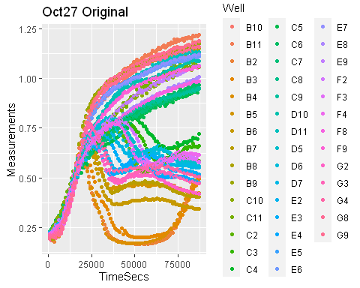

ggplot(data = Oct27Merged2, aes(x = TimeSecs, y = smoothed)) + geom_point(aes(color = Well)) + ggtitle("Oct27 Smoothed")

## Warning: Removed 172 rows containing missing values (geom_point).

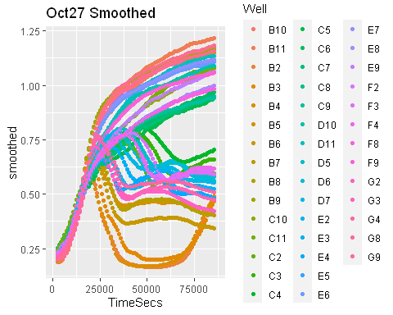

plot(Oct27Merged$TimeSecs[Oct27Merged$Well == "B5"], Oct27Merged$Measurements[Oct27Merged$Well == "B5"], xlab = "Time in seconds", ylab = "Absorbance", main = "Oct27 Cell B5 Original")

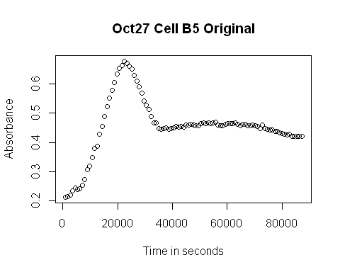

plot(Oct27Merged$TimeSecs[Oct27Merged$Well == "B5"], Oct27Merged$smoothed[Oct27Merged$Well == "B5"], xlab = "Time in seconds", ylab = "Smoothed Absorbance", main = "Oct27 Cell B5 Smoothed")

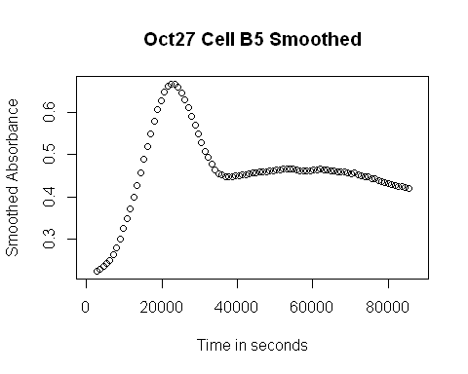

#Nov3Data  
Nov3Merged$TimeSecs <- hms(Nov3Merged$Time)  
Nov3Merged$TimeSecs <- 3600*hour(Nov3Merged$TimeSecs) + 60*minute(Nov3Merged$TimeSecs) + second(Nov3Merged$TimeSecs)  
  
Nov3Merged$smoothed <- smooth_data(x = Nov3Merged$TimeSecs,  
 y = Nov3Merged$Measurements,  
 method = "moving-average",  
 subset_by = Nov3Merged$Well,  
 window_width = 5)  
  
Nov3Merged2 <- Nov3Merged[complete.cases(Nov3Merged[, c("Bacteria", "Phage.Added.", "Media")]), ]  
head(Nov3Merged2, 24)

## file Time Well Measurements Bacteria Phage.Added. Media  
## 14 2021-11-03 Data 0:14:16 B2 0.206 PF Yes KB Media  
## 15 2021-11-03 Data 0:14:16 B3 0.210 PF Yes KB Media  
## 16 2021-11-03 Data 0:14:16 B4 0.209 PF Yes KB Media  
## 17 2021-11-03 Data 0:14:16 B5 0.213 7x CLD Yes KB Media  
## 18 2021-11-03 Data 0:14:16 B6 0.211 7x CLD Yes KB Media  
## 19 2021-11-03 Data 0:14:16 B7 0.215 7x CLD Yes KB Media  
## 20 2021-11-03 Data 0:14:16 B8 0.207 PF No KB Media  
## 21 2021-11-03 Data 0:14:16 B9 0.204 PF No KB Media  
## 22 2021-11-03 Data 0:14:16 B10 0.222 7x CLD No KB Media  
## 23 2021-11-03 Data 0:14:16 B11 0.213 7x CLD No KB Media  
## 26 2021-11-03 Data 0:14:16 C2 0.217 125 ALE Yes KB Media  
## 27 2021-11-03 Data 0:14:16 C3 0.237 125 ALE Yes KB Media  
## 28 2021-11-03 Data 0:14:16 C4 0.227 125 ALE Yes KB Media  
## 29 2021-11-03 Data 0:14:16 C5 0.235 7x EGD Yes KB Media  
## 30 2021-11-03 Data 0:14:16 C6 0.223 7x EGD Yes KB Media  
## 31 2021-11-03 Data 0:14:16 C7 0.244 7x EGD Yes KB Media  
## 32 2021-11-03 Data 0:14:16 C8 0.231 125 ALE No KB Media  
## 33 2021-11-03 Data 0:14:16 C9 0.232 125 ALE No KB Media  
## 34 2021-11-03 Data 0:14:16 C10 0.239 7x EGD No KB Media  
## 35 2021-11-03 Data 0:14:16 C11 0.228 7x EGD No KB Media  
## 38 2021-11-03 Data 0:14:16 D2 0.215 7x EGC Yes KB Media  
## 39 2021-11-03 Data 0:14:16 D3 0.212 7x EGC Yes KB Media  
## 40 2021-11-03 Data 0:14:16 D4 0.245 7x EGC Yes KB Media  
## 41 2021-11-03 Data 0:14:16 D5 0.214 7x ALA Yes KB Media  
## TimeSecs smoothed  
## 14 856 NA  
## 15 856 NA  
## 16 856 NA  
## 17 856 NA  
## 18 856 NA  
## 19 856 NA  
## 20 856 NA  
## 21 856 NA  
## 22 856 NA  
## 23 856 NA  
## 26 856 NA  
## 27 856 NA  
## 28 856 NA  
## 29 856 NA  
## 30 856 NA  
## 31 856 NA  
## 32 856 NA  
## 33 856 NA  
## 34 856 NA  
## 35 856 NA  
## 38 856 NA  
## 39 856 NA  
## 40 856 NA  
## 41 856 NA

ggplot(data = Nov3Merged2, aes(x = TimeSecs, y = Measurements)) + geom_point(aes(color = Well)) + ggtitle("Nov3 Original")

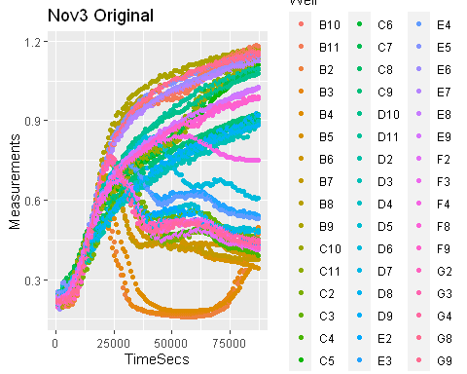

ggplot(data = Nov3Merged2, aes(x = TimeSecs, y = smoothed)) + geom_point(aes(color = Well)) + ggtitle ("Nov3 Smoothed")

## Warning: Removed 192 rows containing missing values (geom_point).

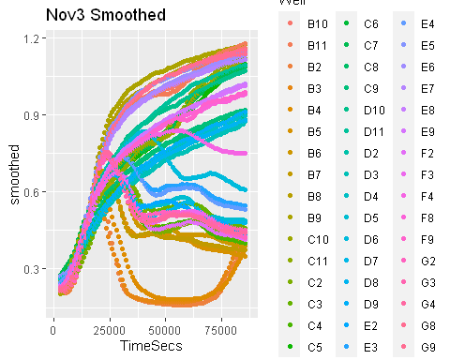

plot(Nov3Merged$TimeSecs[Nov3Merged$Well == "B5"], Nov3Merged$Measurements[Nov3Merged$Well == "B5"], xlab = "Time in seconds", ylab = "Absorbance", main = "Nov3 Cell B5 Original")

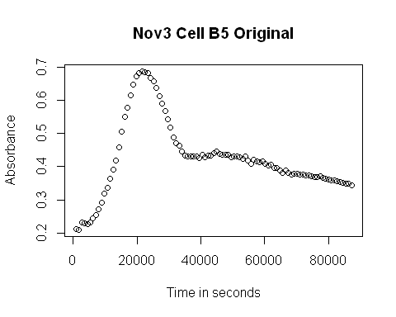

plot(Nov3Merged$TimeSecs[Nov3Merged$Well == "B5"], Nov3Merged$smoothed[Oct27Merged$Well == "B5"], xlab = "Time in seconds", ylab = "Smoothed Absorbance", main = "Nov3 Cell B5 Smoothed")

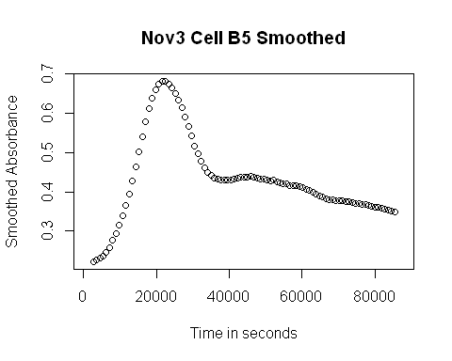

Simple Derivative

#Oct15 Data  
Oct15Merged$deriv <- calc_deriv(x = Oct15Merged$TimeSecs, y = Oct15Merged$smoothed, subset_by = Oct15Merged$Well)  
  
Oct15Merged3 <- Oct15Merged[complete.cases(Oct15Merged[, c("Bacteria..cfu.mL.", "Phage..pfu.mL.", "Media")]), ]  
head(Oct15Merged3, 24)

## file Time Well Measurements Bacteria..cfu.mL. Phage..pfu.mL.  
## 17 2021-10-15 Data 0:14:16 B5 0.192 10^5 10^4  
## 18 2021-10-15 Data 0:14:16 B6 0.195 10^5 10^4  
## 19 2021-10-15 Data 0:14:16 B7 0.195 10^5 10^4  
## 29 2021-10-15 Data 0:14:16 C5 0.186 10^5 10^3  
## 30 2021-10-15 Data 0:14:16 C6 0.193 10^5 10^3  
## 31 2021-10-15 Data 0:14:16 C7 0.200 10^5 10^3  
## 41 2021-10-15 Data 0:14:16 D5 0.191 10^5 10^2  
## 42 2021-10-15 Data 0:14:16 D6 0.202 10^5 10^2  
## 43 2021-10-15 Data 0:14:16 D7 0.198 10^5 10^2  
## 53 2021-10-15 Data 0:14:16 E5 0.098 10^4 10^3  
## 54 2021-10-15 Data 0:14:16 E6 0.096 10^4 10^3  
## 55 2021-10-15 Data 0:14:16 E7 0.096 10^4 10^3  
## 62 2021-10-15 Data 0:14:16 F2 0.126 5 x 10^4 5 x 10^3  
## 63 2021-10-15 Data 0:14:16 F3 0.136 5 x 10^4 5 x 10^3  
## 64 2021-10-15 Data 0:14:16 F4 0.128 5 x 10^4 5 x 10^3  
## 65 2021-10-15 Data 0:14:16 F5 0.101 10^4 10^2  
## 66 2021-10-15 Data 0:14:16 F6 0.099 10^4 10^2  
## 67 2021-10-15 Data 0:14:16 F7 0.096 10^4 10^2  
## 74 2021-10-15 Data 0:14:16 G2 0.140 5 x 10^4 5 x 10^2  
## 75 2021-10-15 Data 0:14:16 G3 0.132 5 x 10^4 5 x 10^2  
## 76 2021-10-15 Data 0:14:16 G4 0.134 5 x 10^4 5 x 10^2  
## 113 2021-10-15 Data 0:29:16 B5 0.189 10^5 10^4  
## 114 2021-10-15 Data 0:29:16 B6 0.186 10^5 10^4  
## 115 2021-10-15 Data 0:29:16 B7 0.189 10^5 10^4  
## Media TimeSecs smoothed deriv  
## 17 KB Media 856 NA NA  
## 18 KB Media 856 NA NA  
## 19 KB Media 856 NA NA  
## 29 KB Media 856 NA NA  
## 30 KB Media 856 NA NA  
## 31 KB Media 856 NA NA  
## 41 KB Media 856 NA NA  
## 42 KB Media 856 NA NA  
## 43 KB Media 856 NA NA  
## 53 KB Media 856 NA NA  
## 54 KB Media 856 NA NA  
## 55 KB Media 856 NA NA  
## 62 KB Media 856 NA NA  
## 63 KB Media 856 NA NA  
## 64 KB Media 856 NA NA  
## 65 KB Media 856 NA NA  
## 66 KB Media 856 NA NA  
## 67 KB Media 856 NA NA  
## 74 KB Media 856 NA NA  
## 75 KB Media 856 NA NA  
## 76 KB Media 856 NA NA  
## 113 KB Media 1756 NA NA  
## 114 KB Media 1756 NA NA  
## 115 KB Media 1756 NA NA

ggplot(data = Oct15Merged3, aes(x = TimeSecs, y = deriv)) + geom_point(aes(color = Well)) + ggtitle("Oct15 Abs Derivative")

## Warning: Removed 105 rows containing missing values (geom_point).

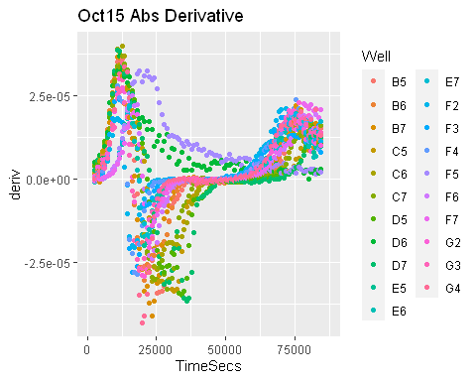

plot(Oct15Merged$TimeSecs[Oct15Merged$Well == "B5"], Oct15Merged$deriv[Oct15Merged$Well == "B5"], xlab = "Time in seconds", ylab = "Derivative(Absorbance)", main = "Oct15 Cell B5 Abs Derivative")

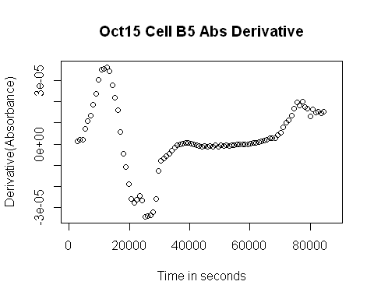

#Oct25Data  
Oct25Merged$deriv <- calc_deriv(x = Oct25Merged$TimeSecs, y = Oct25Merged$smoothed, subset_by = Oct25Merged$Well)  
  
Oct25Merged3 <- Oct25Merged[complete.cases(Oct25Merged[, c("Bacteria", "Phage.Added.", "Media")]), ]  
head(Oct25Merged3, 24)

## file Time Well Measurements Bacteria Phage.Added. Media  
## 14 2021-10-25 Data 0:14:16 B2 0.145 PF Yes KB Media  
## 15 2021-10-25 Data 0:14:16 B3 0.143 PF Yes KB Media  
## 16 2021-10-25 Data 0:14:16 B4 0.149 PF Yes KB Media  
## 17 2021-10-25 Data 0:14:16 B5 0.149 7x CLD Yes KB Media  
## 18 2021-10-25 Data 0:14:16 B6 0.145 7x CLD Yes KB Media  
## 19 2021-10-25 Data 0:14:16 B7 0.146 7x CLD Yes KB Media  
## 20 2021-10-25 Data 0:14:16 B8 0.142 PF No KB Media  
## 21 2021-10-25 Data 0:14:16 B9 0.144 PF No KB Media  
## 22 2021-10-25 Data 0:14:16 B10 0.142 7x CLD No KB Media  
## 23 2021-10-25 Data 0:14:16 B11 0.145 7x CLD No KB Media  
## 26 2021-10-25 Data 0:14:16 C2 0.148 125 ALE Yes KB Media  
## 27 2021-10-25 Data 0:14:16 C3 0.153 125 ALE Yes KB Media  
## 28 2021-10-25 Data 0:14:16 C4 0.164 125 ALE Yes KB Media  
## 29 2021-10-25 Data 0:14:16 C5 0.155 7x EGD Yes KB Media  
## 30 2021-10-25 Data 0:14:16 C6 0.157 7x EGD Yes KB Media  
## 31 2021-10-25 Data 0:14:16 C7 0.162 7x EGD Yes KB Media  
## 32 2021-10-25 Data 0:14:16 C8 0.147 125 ALE No KB Media  
## 33 2021-10-25 Data 0:14:16 C9 0.151 125 ALE No KB Media  
## 34 2021-10-25 Data 0:14:16 C10 0.159 7x EGD No KB Media  
## 35 2021-10-25 Data 0:14:16 C11 0.159 7x EGD No KB Media  
## 38 2021-10-25 Data 0:14:16 D2 0.156 7x EGC Yes KB Media  
## 39 2021-10-25 Data 0:14:16 D3 0.160 7x EGC Yes KB Media  
## 40 2021-10-25 Data 0:14:16 D4 0.160 7x EGC Yes KB Media  
## 41 2021-10-25 Data 0:14:16 D5 0.144 7x ALA Yes KB Media  
## TimeSecs smoothed deriv  
## 14 856 NA NA  
## 15 856 NA NA  
## 16 856 NA NA  
## 17 856 NA NA  
## 18 856 NA NA  
## 19 856 NA NA  
## 20 856 NA NA  
## 21 856 NA NA  
## 22 856 NA NA  
## 23 856 NA NA  
## 26 856 NA NA  
## 27 856 NA NA  
## 28 856 NA NA  
## 29 856 NA NA  
## 30 856 NA NA  
## 31 856 NA NA  
## 32 856 NA NA  
## 33 856 NA NA  
## 34 856 NA NA  
## 35 856 NA NA  
## 38 856 NA NA  
## 39 856 NA NA  
## 40 856 NA NA  
## 41 856 NA NA

ggplot(data = Oct25Merged3, aes(x = TimeSecs, y = deriv)) + geom_point(aes(color = Well)) + ggtitle("Oct25 Abs Derivative")

## Warning: Removed 240 rows containing missing values (geom_point).

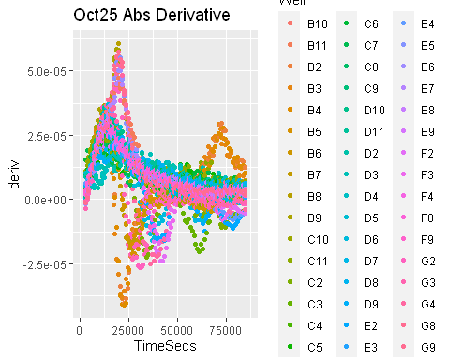

plot(Oct25Merged$TimeSecs[Oct25Merged$Well == "B5"], Oct25Merged$deriv[Oct25Merged$Well == "B5"], xlab = "Time in seconds", ylab = "Derivative(Absorbance)", main = "Oct25 Cell B5 Abs Derivative")

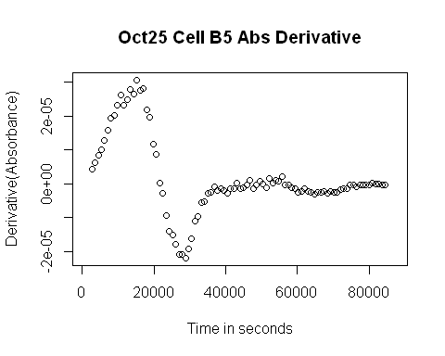

#Oct27 Data  
Oct27Merged$deriv <- calc_deriv(x = Oct27Merged$TimeSecs, y = Oct27Merged$smoothed, subset_by = Oct27Merged$Well)  
  
Oct27Merged3 <- Oct27Merged[complete.cases(Oct27Merged[, c("Bacteria", "Phage.Added.", "Media")]), ]  
head(Oct27Merged3, 24)

## file Time Well Measurements Bacteria Phage.Added. Media  
## 14 2021-10-27 Data 0:14:16 B2 0.198 PF Yes KB Media  
## 15 2021-10-27 Data 0:14:16 B3 0.199 PF Yes KB Media  
## 16 2021-10-27 Data 0:14:16 B4 0.198 PF Yes KB Media  
## 17 2021-10-27 Data 0:14:16 B5 0.212 7x CLD Yes KB Media  
## 18 2021-10-27 Data 0:14:16 B6 0.208 7x CLD Yes KB Media  
## 19 2021-10-27 Data 0:14:16 B7 0.213 7x CLD Yes KB Media  
## 20 2021-10-27 Data 0:14:16 B8 0.194 PF No KB Media  
## 21 2021-10-27 Data 0:14:16 B9 0.197 PF No KB Media  
## 22 2021-10-27 Data 0:14:16 B10 0.205 7x CLD No KB Media  
## 23 2021-10-27 Data 0:14:16 B11 0.210 7x CLD No KB Media  
## 26 2021-10-27 Data 0:14:16 C2 0.208 125 ALE Yes KB Media  
## 27 2021-10-27 Data 0:14:16 C3 0.206 125 ALE Yes KB Media  
## 28 2021-10-27 Data 0:14:16 C4 0.194 125 ALE Yes KB Media  
## 29 2021-10-27 Data 0:14:16 C5 0.219 7x EGD Yes KB Media  
## 30 2021-10-27 Data 0:14:16 C6 0.221 7x EGD Yes KB Media  
## 31 2021-10-27 Data 0:14:16 C7 0.228 7x EGD Yes KB Media  
## 32 2021-10-27 Data 0:14:16 C8 0.202 125 ALE No KB Media  
## 33 2021-10-27 Data 0:14:16 C9 0.206 125 ALE No KB Media  
## 34 2021-10-27 Data 0:14:16 C10 0.203 7x EGD No KB Media  
## 35 2021-10-27 Data 0:14:16 C11 0.206 7x EGD No KB Media  
## 41 2021-10-27 Data 0:14:16 D5 0.205 7x ALA Yes KB Media  
## 42 2021-10-27 Data 0:14:16 D6 0.212 7x ALA Yes KB Media  
## 43 2021-10-27 Data 0:14:16 D7 0.218 7x ALA Yes KB Media  
## 46 2021-10-27 Data 0:14:16 D10 0.194 7x ALA No KB Media  
## TimeSecs smoothed deriv  
## 14 856 NA NA  
## 15 856 NA NA  
## 16 856 NA NA  
## 17 856 NA NA  
## 18 856 NA NA  
## 19 856 NA NA  
## 20 856 NA NA  
## 21 856 NA NA  
## 22 856 NA NA  
## 23 856 NA NA  
## 26 856 NA NA  
## 27 856 NA NA  
## 28 856 NA NA  
## 29 856 NA NA  
## 30 856 NA NA  
## 31 856 NA NA  
## 32 856 NA NA  
## 33 856 NA NA  
## 34 856 NA NA  
## 35 856 NA NA  
## 41 856 NA NA  
## 42 856 NA NA  
## 43 856 NA NA  
## 46 856 NA NA

ggplot(data = Oct27Merged3, aes(x = TimeSecs, y = deriv)) + geom_point(aes(color = Well)) + ggtitle("Oct27 Abs Derivative")

## Warning: Removed 215 rows containing missing values (geom_point).

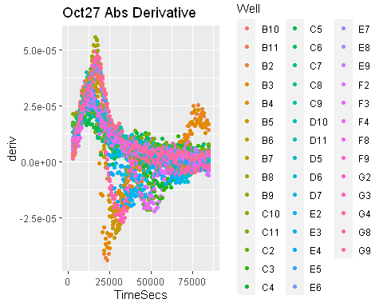

plot(Oct27Merged$TimeSecs[Oct27Merged$Well == "B5"], Oct27Merged$deriv[Oct27Merged$Well == "B5"], xlab = "Time in seconds", ylab = "Derivative(Absorbance)", main = "Oct27 Cell B5 Abs Derivative")

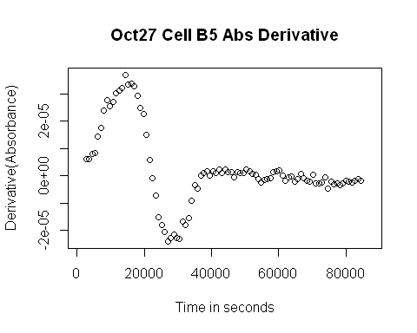

#Nov3 Data  
Nov3Merged$deriv <- calc_deriv(x = Nov3Merged$TimeSecs, y = Nov3Merged$smoothed, subset_by = Nov3Merged$Well)  
  
Nov3Merged3 <- Nov3Merged[complete.cases(Nov3Merged[, c("Bacteria", "Phage.Added.", "Media")]), ]  
head(Nov3Merged3, 24)

## file Time Well Measurements Bacteria Phage.Added. Media  
## 14 2021-11-03 Data 0:14:16 B2 0.206 PF Yes KB Media  
## 15 2021-11-03 Data 0:14:16 B3 0.210 PF Yes KB Media  
## 16 2021-11-03 Data 0:14:16 B4 0.209 PF Yes KB Media  
## 17 2021-11-03 Data 0:14:16 B5 0.213 7x CLD Yes KB Media  
## 18 2021-11-03 Data 0:14:16 B6 0.211 7x CLD Yes KB Media  
## 19 2021-11-03 Data 0:14:16 B7 0.215 7x CLD Yes KB Media  
## 20 2021-11-03 Data 0:14:16 B8 0.207 PF No KB Media  
## 21 2021-11-03 Data 0:14:16 B9 0.204 PF No KB Media  
## 22 2021-11-03 Data 0:14:16 B10 0.222 7x CLD No KB Media  
## 23 2021-11-03 Data 0:14:16 B11 0.213 7x CLD No KB Media  
## 26 2021-11-03 Data 0:14:16 C2 0.217 125 ALE Yes KB Media  
## 27 2021-11-03 Data 0:14:16 C3 0.237 125 ALE Yes KB Media  
## 28 2021-11-03 Data 0:14:16 C4 0.227 125 ALE Yes KB Media  
## 29 2021-11-03 Data 0:14:16 C5 0.235 7x EGD Yes KB Media  
## 30 2021-11-03 Data 0:14:16 C6 0.223 7x EGD Yes KB Media  
## 31 2021-11-03 Data 0:14:16 C7 0.244 7x EGD Yes KB Media  
## 32 2021-11-03 Data 0:14:16 C8 0.231 125 ALE No KB Media  
## 33 2021-11-03 Data 0:14:16 C9 0.232 125 ALE No KB Media  
## 34 2021-11-03 Data 0:14:16 C10 0.239 7x EGD No KB Media  
## 35 2021-11-03 Data 0:14:16 C11 0.228 7x EGD No KB Media  
## 38 2021-11-03 Data 0:14:16 D2 0.215 7x EGC Yes KB Media  
## 39 2021-11-03 Data 0:14:16 D3 0.212 7x EGC Yes KB Media  
## 40 2021-11-03 Data 0:14:16 D4 0.245 7x EGC Yes KB Media  
## 41 2021-11-03 Data 0:14:16 D5 0.214 7x ALA Yes KB Media  
## TimeSecs smoothed deriv  
## 14 856 NA NA  
## 15 856 NA NA  
## 16 856 NA NA  
## 17 856 NA NA  
## 18 856 NA NA  
## 19 856 NA NA  
## 20 856 NA NA  
## 21 856 NA NA  
## 22 856 NA NA  
## 23 856 NA NA  
## 26 856 NA NA  
## 27 856 NA NA  
## 28 856 NA NA  
## 29 856 NA NA  
## 30 856 NA NA  
## 31 856 NA NA  
## 32 856 NA NA  
## 33 856 NA NA  
## 34 856 NA NA  
## 35 856 NA NA  
## 38 856 NA NA  
## 39 856 NA NA  
## 40 856 NA NA  
## 41 856 NA NA

ggplot(data = Nov3Merged3, aes(x = TimeSecs, y = deriv)) + geom_point(aes(color = Well)) + ggtitle("Nov3 Abs Derivative")

## Warning: Removed 240 rows containing missing values (geom_point).

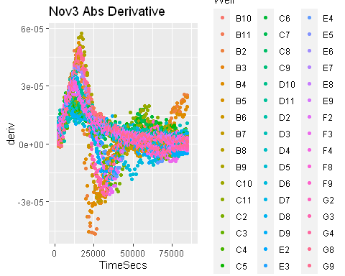

plot(Nov3Merged$TimeSecs[Nov3Merged$Well == "B5"], Nov3Merged$deriv[Nov3Merged$Well == "B5"], xlab = "Time in seconds", ylab = "Derivative(Absorbance)", main = "Nov3 Cell B5 Abs Derivative")

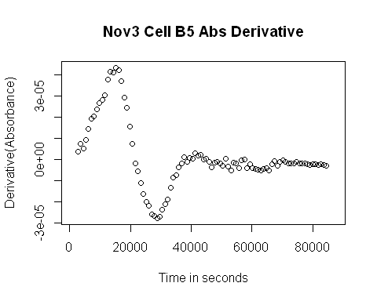

Grouping Data and Making Calculations

#Oct15 Data  
Oct15Grouped <- group_by(Oct15Merged, Bacteria..cfu.mL., Phage..pfu.mL., Well)  
  
head(Oct15Grouped,32)

## # A tibble: 32 x 10  
## # Groups: Bacteria..cfu.mL., Phage..pfu.mL., Well [32]  
## file Time Well Measurements Bacteria..cfu.m~ Phage..pfu.mL. Media TimeSecs  
## <chr> <chr> <chr> <dbl> <chr> <chr> <chr> <dbl>  
## 1 2021~ 0:14~ A1 0.086 <NA> <NA> <NA> 856  
## 2 2021~ 0:14~ A2 0.086 <NA> <NA> <NA> 856  
## 3 2021~ 0:14~ A3 0.088 <NA> <NA> <NA> 856  
## 4 2021~ 0:14~ A4 0.09 <NA> <NA> <NA> 856  
## 5 2021~ 0:14~ A5 0.088 <NA> <NA> <NA> 856  
## 6 2021~ 0:14~ A6 0.085 <NA> <NA> <NA> 856  
## 7 2021~ 0:14~ A7 0.086 <NA> <NA> <NA> 856  
## 8 2021~ 0:14~ A8 0.087 <NA> <NA> <NA> 856  
## 9 2021~ 0:14~ A9 0.086 <NA> <NA> <NA> 856  
## 10 2021~ 0:14~ A10 0.087 <NA> <NA> <NA> 856  
## # ... with 22 more rows, and 2 more variables: smoothed <dbl>, deriv <dbl>

Oct15Sum <- summarize(Oct15Grouped,   
 FirstPeakX = first_peak(deriv, x = TimeSecs, return = "x", width_limit_n = 39),  
 FirstPeakY = first_peak(deriv, return = "y", width_limit_n = 39),  
 FirstPeakXSm = first_peak(smoothed, x = TimeSecs, return = "x", width_limit_n = 39),  
 FirstPeakYSm = first_peak(smoothed, return = "y", width_limit_n = 39),  
 Auc = auc(x = TimeSecs, y = smoothed))

## `summarise()` has grouped output by 'Bacteria..cfu.mL.', 'Phage..pfu.mL.'. You can override using the `.groups` argument.

head(Oct15Sum, 50)

## # A tibble: 50 x 8  
## # Groups: Bacteria..cfu.mL., Phage..pfu.mL. [11]  
## Bacteria..cfu.mL. Phage..pfu.mL. Well FirstPeakX FirstPeakY FirstPeakXSm  
## <chr> <chr> <chr> <dbl> <dbl> <dbl>  
## 1 10^4 10^2 F5 21556 0.0000327 NA  
## 2 10^4 10^2 F6 16156 0.0000251 20656  
## 3 10^4 10^2 F7 17056 0.0000200 20656  
## 4 10^4 10^3 E5 15256 0.0000244 18855  
## 5 10^4 10^3 E6 15256 0.0000211 18855  
## 6 10^4 10^3 E7 15256 0.0000220 18855  
## 7 10^4 <NA> E2 21556 0.0000340 NA  
## 8 10^4 <NA> E3 21556 0.0000338 NA  
## 9 10^4 <NA> E4 19756 0.0000456 NA  
## 10 10^5 10^2 D5 13456 0.0000333 21556  
## # ... with 40 more rows, and 2 more variables: FirstPeakYSm <dbl>, Auc <dbl>

Oct15Sum3 <- Oct15Sum[complete.cases(Oct15Sum[, c("Bacteria..cfu.mL.", "Phage..pfu.mL.")]), ]  
  
plot(Oct15Merged$TimeSecs[Oct15Merged$Well == "B5"], Oct15Merged$deriv[Oct15Merged$Well == "B5"], xlab = "Time in seconds", ylab = "Derivative(Absorbance)", main = "Oct15 Cell B5 Abs Derivative")  
points(x = Oct15Sum$FirstPeakX[Oct15Sum$Well =="B5"],  
 y = Oct15Sum$FirstPeakY[Oct15Sum$Well == "B5"],  
 pch = 16, cex = 2)

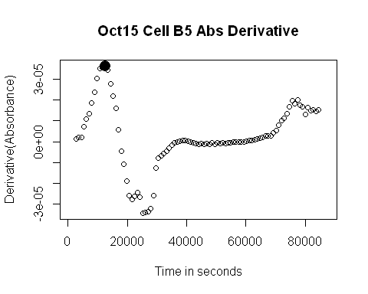

#Oct25 Data  
Oct25Grouped <- group_by(Oct25Merged, Bacteria, Phage.Added., Well)  
  
head(Oct25Grouped,32)

## # A tibble: 32 x 10  
## # Groups: Bacteria, Phage.Added., Well [32]  
## file Time Well Measurements Bacteria Phage.Added. Media TimeSecs smoothed  
## <chr> <chr> <chr> <dbl> <chr> <chr> <chr> <dbl> <dbl>  
## 1 2021-~ 0:14~ A1 0.087 <NA> <NA> <NA> 856 NA  
## 2 2021-~ 0:14~ A2 0.086 <NA> <NA> <NA> 856 NA  
## 3 2021-~ 0:14~ A3 0.086 <NA> <NA> <NA> 856 NA  
## 4 2021-~ 0:14~ A4 0.087 <NA> <NA> <NA> 856 NA  
## 5 2021-~ 0:14~ A5 0.085 <NA> <NA> <NA> 856 NA  
## 6 2021-~ 0:14~ A6 0.085 <NA> <NA> <NA> 856 NA  
## 7 2021-~ 0:14~ A7 0.085 <NA> <NA> <NA> 856 NA  
## 8 2021-~ 0:14~ A8 0.085 <NA> <NA> <NA> 856 NA  
## 9 2021-~ 0:14~ A9 0.086 <NA> <NA> <NA> 856 NA  
## 10 2021-~ 0:14~ A10 0.086 <NA> <NA> <NA> 856 NA  
## # ... with 22 more rows, and 1 more variable: deriv <dbl>

Oct25Sum <- summarize(Oct25Grouped,   
 FirstPeakX = first_peak(deriv, x = TimeSecs, return = "x", width_limit_n = 39),  
 FirstPeakY = first_peak(deriv, return = "y", width_limit_n = 39),  
 Auc = auc(x = TimeSecs, y = smoothed))

## `summarise()` has grouped output by 'Bacteria', 'Phage.Added.'. You can override using the `.groups` argument.

head(Oct25Sum, 50)

## # A tibble: 50 x 6  
## # Groups: Bacteria, Phage.Added. [20]  
## Bacteria Phage.Added. Well FirstPeakX FirstPeakY Auc  
## <chr> <chr> <chr> <dbl> <dbl> <dbl>  
## 1 125 ALA No F8 12556 0.0000331 62636.  
## 2 125 ALA No F9 11656 0.0000358 63347.  
## 3 125 ALA Yes F2 13456 0.000028 39104.  
## 4 125 ALA Yes F3 12556 0.0000267 41735.  
## 5 125 ALA Yes F4 16156 0.0000276 56962.  
## 6 125 ALE No C8 17056 0.0000313 59199.  
## 7 125 ALE No C9 17956 0.0000309 59385.  
## 8 125 ALE Yes C2 18856 0.0000284 32381.  
## 9 125 ALE Yes C3 12556 0.0000249 47740.  
## 10 125 ALE Yes C4 14356 0.0000251 55413.  
## # ... with 40 more rows

Oct25Sum3 <- Oct25Sum[complete.cases(Oct25Sum[, c("Bacteria", "Phage.Added.")]), ]  
  
plot(Oct25Merged$TimeSecs[Oct25Merged$Well == "B5"], Oct25Merged$deriv[Oct25Merged$Well == "B5"], xlab = "Time in seconds", ylab = "Derivative(Absorbance)", main = "Oct25 Cell B5 Abs Derivative")  
points(x = Oct25Sum$FirstPeakX[Oct25Sum$Well =="B5"],  
 y = Oct25Sum$FirstPeakY[Oct25Sum$Well == "B5"],  
 pch = 16, cex = 2)

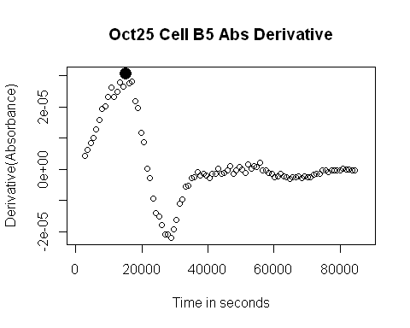

#Oct27 Data  
Oct27Grouped <- group_by(Oct27Merged,Bacteria, Phage.Added., Well)  
  
head(Oct27Grouped,32)

## # A tibble: 32 x 10  
## # Groups: Bacteria, Phage.Added., Well [32]  
## file Time Well Measurements Bacteria Phage.Added. Media TimeSecs smoothed  
## <chr> <chr> <chr> <dbl> <chr> <chr> <chr> <dbl> <dbl>  
## 1 2021-~ 0:14~ A1 0.086 <NA> <NA> <NA> 856 NA  
## 2 2021-~ 0:14~ A2 0.085 <NA> <NA> <NA> 856 NA  
## 3 2021-~ 0:14~ A3 0.086 <NA> <NA> <NA> 856 NA  
## 4 2021-~ 0:14~ A4 0.085 <NA> <NA> <NA> 856 NA  
## 5 2021-~ 0:14~ A5 0.085 <NA> <NA> <NA> 856 NA  
## 6 2021-~ 0:14~ A6 0.087 <NA> <NA> <NA> 856 NA  
## 7 2021-~ 0:14~ A7 0.085 <NA> <NA> <NA> 856 NA  
## 8 2021-~ 0:14~ A8 0.086 <NA> <NA> <NA> 856 NA  
## 9 2021-~ 0:14~ A9 0.088 <NA> <NA> <NA> 856 NA  
## 10 2021-~ 0:14~ A10 0.088 <NA> <NA> <NA> 856 NA  
## # ... with 22 more rows, and 1 more variable: deriv <dbl>

Oct27Sum <- summarize(Oct27Grouped,   
 FirstPeakX = first_peak(deriv, x = TimeSecs, return = "x", width_limit_n = 39),  
 FirstPeakY = first_peak(deriv, return = "y", width_limit_n = 39),  
 Auc = auc(x = TimeSecs, y = smoothed))

## `summarise()` has grouped output by 'Bacteria', 'Phage.Added.'. You can override using the `.groups` argument.

head(Oct27Sum, 50)

## # A tibble: 50 x 6  
## # Groups: Bacteria, Phage.Added. [18]  
## Bacteria Phage.Added. Well FirstPeakX FirstPeakY Auc  
## <chr> <chr> <chr> <dbl> <dbl> <dbl>  
## 1 125 ALA No F8 10756 0.0000307 61668.  
## 2 125 ALA No F9 9856 0.0000362 68091.  
## 3 125 ALA Yes F2 13456 0.0000298 49695.  
## 4 125 ALA Yes F3 13456 0.0000307 48713.  
## 5 125 ALA Yes F4 12556 0.0000324 49010.  
## 6 125 ALE No C8 11656 0.0000298 60513.  
## 7 125 ALE No C9 12556 0.0000302 60503.  
## 8 125 ALE Yes C2 11656 0.0000318 47236.  
## 9 125 ALE Yes C3 15256 0.0000300 50711.  
## 10 125 ALE Yes C4 14356 0.0000324 53458.  
## # ... with 40 more rows

Oct27Sum3 <- Oct27Sum[complete.cases(Oct27Sum[, c("Bacteria", "Phage.Added.")]), ]  
  
plot(Oct27Merged$TimeSecs[Oct27Merged$Well == "B5"], Oct27Merged$deriv[Oct27Merged$Well == "B5"], xlab = "Time in seconds", ylab = "Derivative(Absorbance)", main = "Oct27 Cell B5 Abs Derivative")  
points(x = Oct27Sum$FirstPeakX[Oct27Sum$Well =="B5"],  
 y = Oct27Sum$FirstPeakY[Oct27Sum$Well == "B5"],  
 pch = 16, cex = 2)

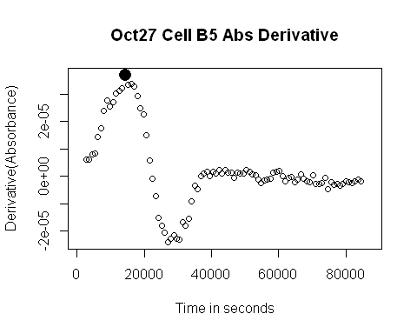

#Nov3 Data  
Nov3Grouped <- group_by(Nov3Merged, Bacteria, Phage.Added., Well)  
  
head(Nov3Grouped,32)

## # A tibble: 32 x 10  
## # Groups: Bacteria, Phage.Added., Well [32]  
## file Time Well Measurements Bacteria Phage.Added. Media TimeSecs smoothed  
## <chr> <chr> <chr> <dbl> <chr> <chr> <chr> <dbl> <dbl>  
## 1 2021-~ 0:14~ A1 0.086 <NA> <NA> <NA> 856 NA  
## 2 2021-~ 0:14~ A2 0.085 <NA> <NA> <NA> 856 NA  
## 3 2021-~ 0:14~ A3 0.086 <NA> <NA> <NA> 856 NA  
## 4 2021-~ 0:14~ A4 0.087 <NA> <NA> <NA> 856 NA  
## 5 2021-~ 0:14~ A5 0.086 <NA> <NA> <NA> 856 NA  
## 6 2021-~ 0:14~ A6 0.085 <NA> <NA> <NA> 856 NA  
## 7 2021-~ 0:14~ A7 0.085 <NA> <NA> <NA> 856 NA  
## 8 2021-~ 0:14~ A8 0.085 <NA> <NA> <NA> 856 NA  
## 9 2021-~ 0:14~ A9 0.086 <NA> <NA> <NA> 856 NA  
## 10 2021-~ 0:14~ A10 0.087 <NA> <NA> <NA> 856 NA  
## # ... with 22 more rows, and 1 more variable: deriv <dbl>

Nov3Sum <- summarize(Nov3Grouped,   
 FirstPeakX = first_peak(deriv, x = TimeSecs, return = "x", width_limit_n = 39),  
 FirstPeakY = first_peak(deriv, return = "y", width_limit_n = 39),  
 Auc = auc(x = TimeSecs, y = smoothed))

## `summarise()` has grouped output by 'Bacteria', 'Phage.Added.'. You can override using the `.groups` argument.

head(Nov3Sum, 50)

## # A tibble: 50 x 6  
## # Groups: Bacteria, Phage.Added. [20]  
## Bacteria Phage.Added. Well FirstPeakX FirstPeakY Auc  
## <chr> <chr> <chr> <dbl> <dbl> <dbl>  
## 1 125 ALA No F8 12556 0.0000316 62314.  
## 2 125 ALA No F9 13456 0.0000313 62782.  
## 3 125 ALA Yes F2 13456 0.0000316 39716.  
## 4 125 ALA Yes F3 13456 0.0000284 41414.  
## 5 125 ALA Yes F4 12556 0.0000338 57444.  
## 6 125 ALE No C8 12556 0.0000218 56525.  
## 7 125 ALE No C9 12556 0.0000242 57338.  
## 8 125 ALE Yes C2 17956 0.0000249 38297.  
## 9 125 ALE Yes C3 17056 0.0000218 41513.  
## 10 125 ALE Yes C4 17056 0.0000236 37877.  
## # ... with 40 more rows

Nov3Sum3 <- Nov3Sum[complete.cases(Nov3Sum[, c("Bacteria", "Phage.Added.")]), ]  
  
plot(Nov3Merged$TimeSecs[Nov3Merged$Well == "B5"], Nov3Merged$deriv[Nov3Merged$Well == "B5"], xlab = "Time in seconds", ylab = "Derivative(Absorbance)", main = "Nov3 Cell B5 Abs Derivative")  
points(x = Nov3Sum$FirstPeakX[Nov3Sum$Well =="B5"],  
 y = Nov3Sum$FirstPeakY[Nov3Sum$Well == "B5"],  
 pch = 16, cex = 2)

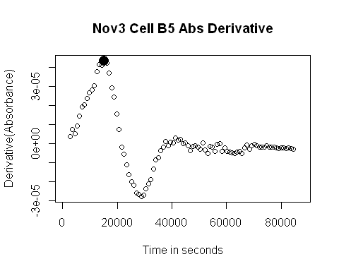

Some Plots

#Oct15 Data  
ggplot(data = Oct15Sum3, aes(x = FirstPeakX, y = Auc)) + geom_point(aes(color = Bacteria..cfu.mL., shape = Phage..pfu.mL.)) + ggtitle("Oct15 Data")

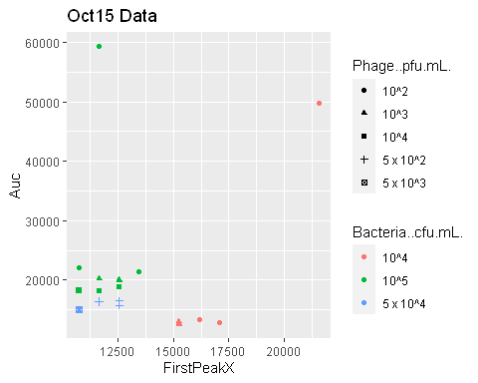

ggplot(data = Oct15Sum3, aes(x = FirstPeakX, y = FirstPeakY)) + geom_point(aes(color = Well)) + ggtitle("Oct15 Data")

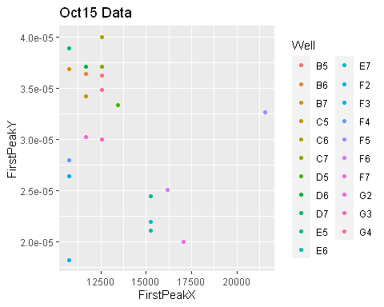

ggplot(data = Oct15Sum3, aes(x = FirstPeakY, y = Auc)) + geom_point(aes(color = Well)) + ggtitle("Oct15 Data")

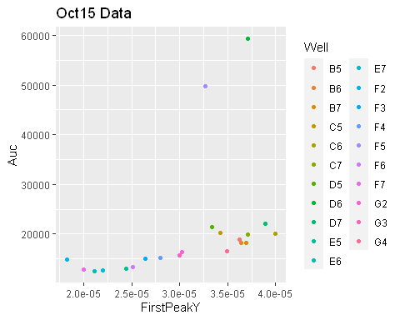

ggplot(data = Oct15Sum3, aes(x = FirstPeakXSm, y = Auc)) + geom_point(aes(color = Bacteria..cfu.mL., shape = Phage..pfu.mL.)) + ggtitle("Oct15 Data")

## Warning: Removed 2 rows containing missing values (geom_point).

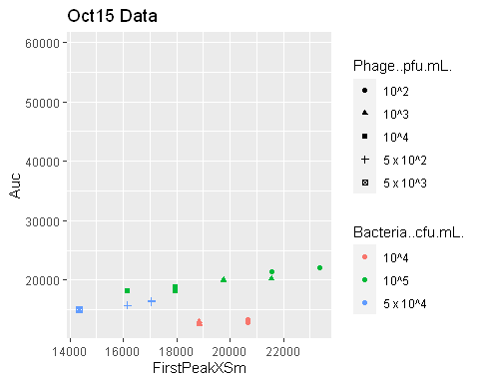

ggplot(data = Oct15Sum3, aes(x = FirstPeakXSm, y = FirstPeakYSm)) + geom_point(aes(color = Well)) + ggtitle("Oct15 Data")

## Warning: Removed 2 rows containing missing values (geom_point).

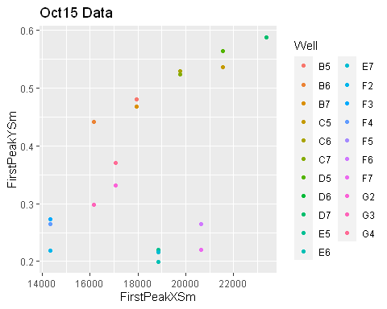

ggplot(data = Oct15Sum3, aes(x = FirstPeakYSm, y = Auc)) + geom_point(aes(color = Well)) + ggtitle("Oct15 Data")

## Warning: Removed 2 rows containing missing values (geom_point).

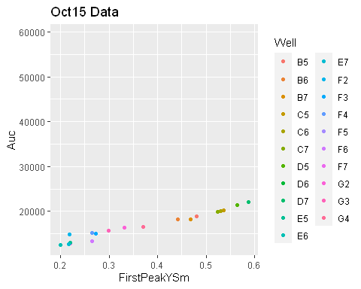

ggplot(data = Oct15Sum3, aes(x = Phage..pfu.mL., y = Auc)) + geom_point(aes(color = Bacteria..cfu.mL.)) + ggtitle("Oct15 Data")

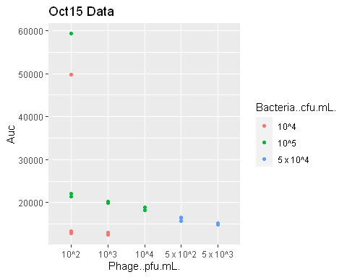

ggplot(data = Oct15Sum3, aes(x = Phage..pfu.mL., y = FirstPeakX)) + geom_point(aes(color = Bacteria..cfu.mL.)) + ggtitle("Oct15 Data")

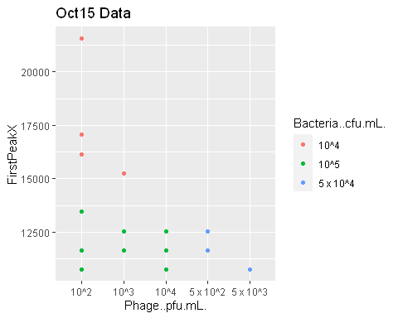

ggplot(data = Oct15Sum3, aes(x = Phage..pfu.mL., y = FirstPeakY)) + geom_point(aes(color = Bacteria..cfu.mL.)) + ggtitle("Oct15 Data")

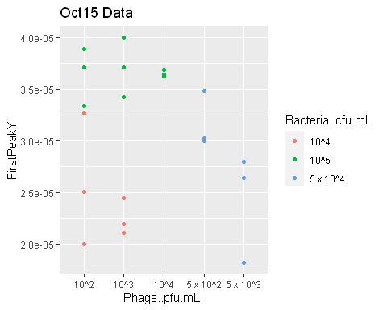

#Oct25 Data  
ggplot(data = Oct25Sum3, aes(x = Bacteria, y = FirstPeakX)) + geom_point(aes(color = Phage.Added.)) + ggtitle("Oct25 Data")

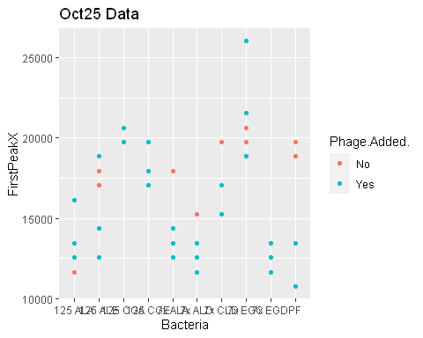

ggplot(data = Oct25Sum3, aes(x = Bacteria, y = FirstPeakY)) + geom_point(aes(color = Phage.Added.)) + ggtitle("Oct25 Data")

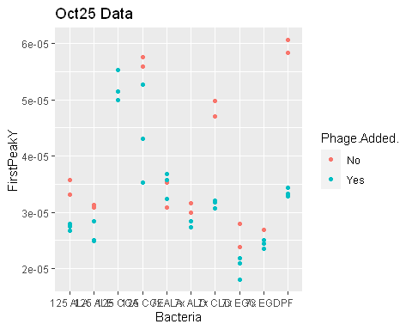

ggplot(data = Oct25Sum3, aes(x = Bacteria, y = Auc)) + geom_point(aes(color = Phage.Added.)) + ggtitle("Oct25 Data")

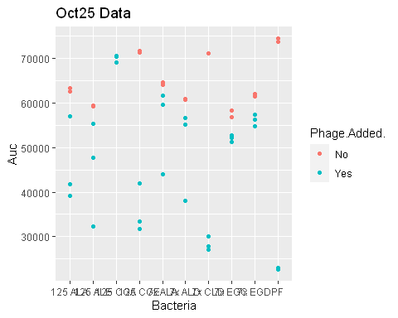

ggplot(data = Oct25Sum3, aes(x = FirstPeakX, y = FirstPeakY)) + geom_point(aes(color = Bacteria, shape = Phage.Added.)) + ggtitle("Oct25 Data")

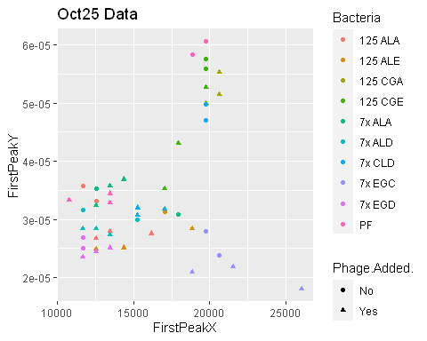

ggplot(data = Oct25Sum3, aes(x = FirstPeakX, y = Auc)) + geom_point(aes(color = Bacteria, shape = Phage.Added.)) + ggtitle("Oct25 Data")

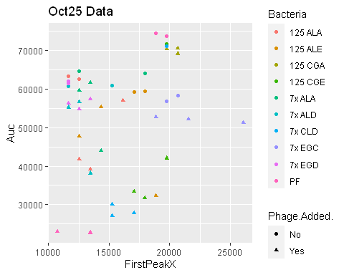

ggplot(data = Oct25Sum3, aes(x = FirstPeakY, y = Auc)) + geom_point(aes(color = Bacteria, shape = Phage.Added.)) + ggtitle("Oct25 Data")

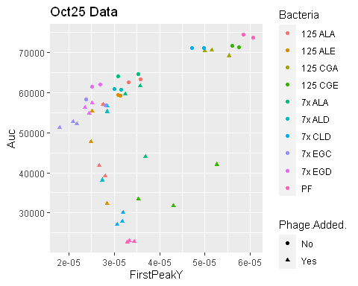

#Oct27 Data  
ggplot(data = Oct27Sum3, aes(x = Bacteria, y = FirstPeakX)) + geom_point(aes(color = Phage.Added.)) + ggtitle("Oct27 Data")

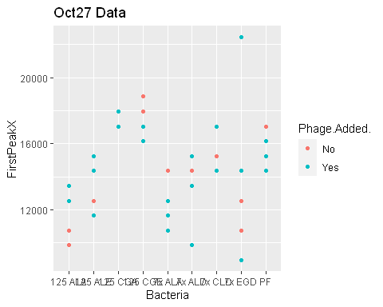

ggplot(data = Oct27Sum3, aes(x = Bacteria, y = FirstPeakY)) + geom_point(aes(color = Phage.Added.)) + ggtitle("Oct27 Data")

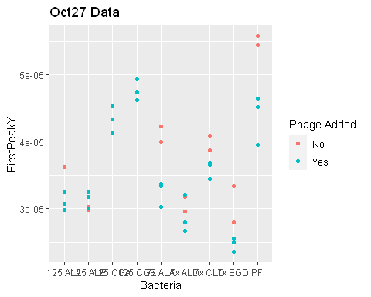

ggplot(data = Oct27Sum3, aes(x = Bacteria, y = Auc)) + geom_point(aes(color = Phage.Added.)) + ggtitle("Oct27 Data")

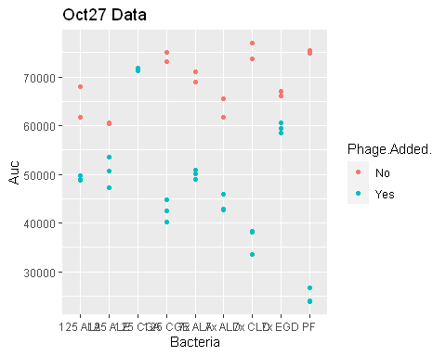

ggplot(data = Oct27Sum3, aes(x = FirstPeakX, y = FirstPeakY)) + geom_point(aes(color = Bacteria, shape = Phage.Added.)) + ggtitle("Oct27 Data")

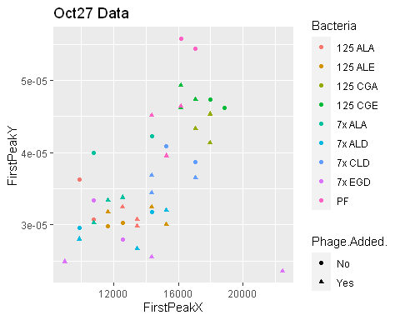

ggplot(data = Oct27Sum3, aes(x = FirstPeakX, y = Auc)) + geom_point(aes(color = Bacteria, shape = Phage.Added.)) + ggtitle("Oct27 Data")

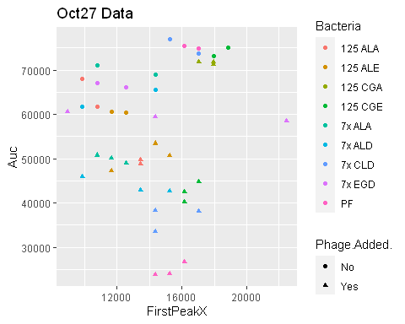

ggplot(data = Oct27Sum3, aes(x = FirstPeakY, y = Auc)) + geom_point(aes(color = Bacteria, shape = Phage.Added.)) + ggtitle("Oct27 Data")

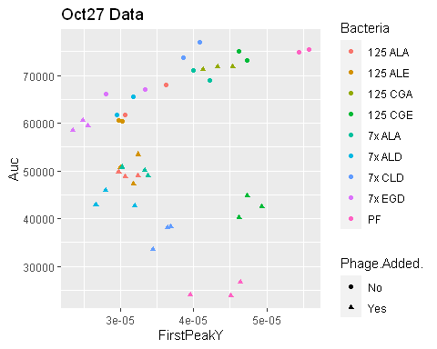

#Nov3 Data  
ggplot(data = Nov3Sum3, aes(x = Bacteria, y = FirstPeakX)) + geom_point(aes(color = Phage.Added.)) + ggtitle("Nov3 Data")

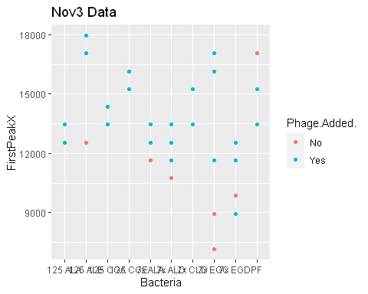

ggplot(data = Nov3Sum3, aes(x = Bacteria, y = FirstPeakY)) + geom_point(aes(color = Phage.Added.)) + ggtitle("Nov3 Data")

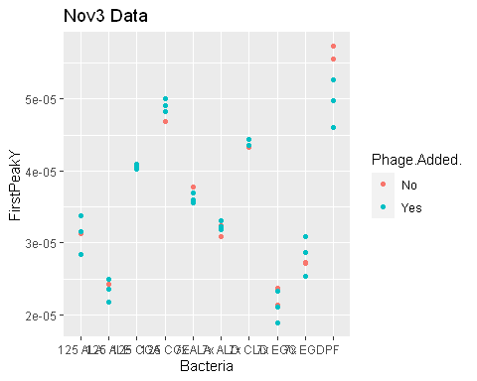

ggplot(data = Nov3Sum3, aes(x = Bacteria, y = Auc)) + geom_point(aes(color = Phage.Added.)) + ggtitle("Nov3 Data")

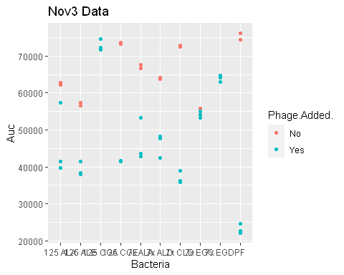

ggplot(data = Nov3Sum3, aes(x = FirstPeakX, y = FirstPeakY)) + geom_point(aes(color = Bacteria, shape = Phage.Added.)) + ggtitle("Nov3 Data")

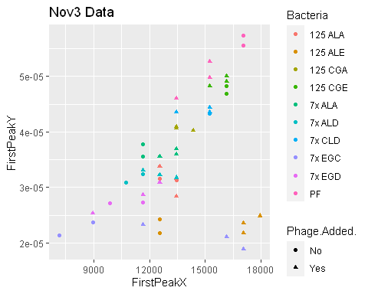

ggplot(data = Nov3Sum3, aes(x = FirstPeakX, y = Auc)) + geom_point(aes(color = Bacteria, shape = Phage.Added.)) + ggtitle("Nov3 Data")

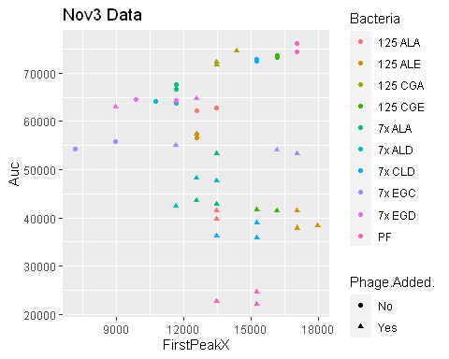

ggplot(data = Nov3Sum3, aes(x = FirstPeakY, y = Auc)) + geom_point(aes(color = Bacteria, shape = Phage.Added.)) + ggtitle("Nov3 Data")

